(priority: high) BUG: WCIS Storage Console View Events - Associate all events with a telemetry system.
statement of the problem:
The View Events tab does not show an associated telemetry system with every event that should have an associated telemetry system. Especially for dual telemetry stations, this is a helpful piece of debugging info that should be included with all events. Even for storage errors the data comes from some telemetry system associated with the station. When using a filter, events could be missed if a telemetry system is not assigned. For events tide to a system wide issue, a label like SYSTEM_WIDE should be used.
Screenshot Examples:
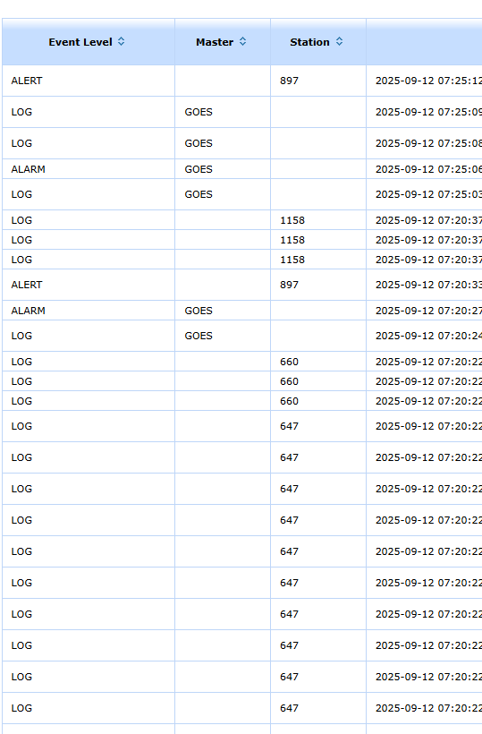

expected results: All events show an associated telemetry type or should state something like SYSTEM_WIDE for non-station related events.

(priority: high) BUG: WCIS Storage Console View Events - Missing station IDs for many events
statement of the problem: Not all events show an associated station ID. If an event is truly not associated with any station do not leave them blank. Mark them as something else like Network Issue or something along those lines. When a DCO filters by station or DCO or state does not show any events that are not associated with the list of stations filtered for.

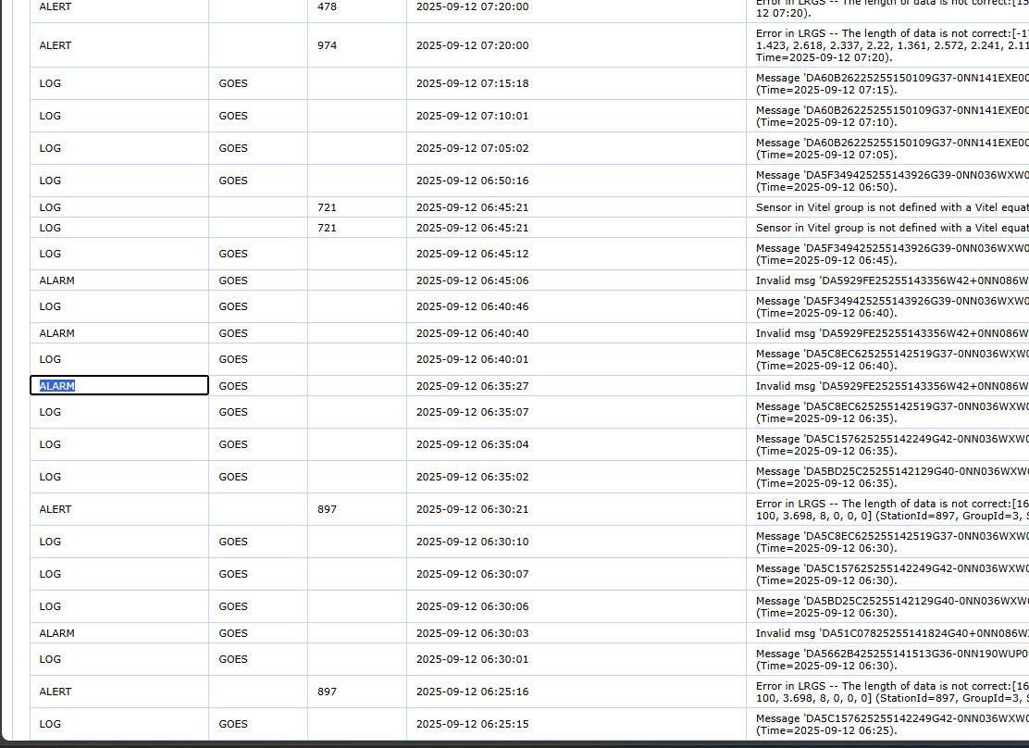
expected results: All event logs should have an associated station ID or some other tag representing that the event is not associated with a specific station. Filtering than by station or group of stations would actual show all the events for that station or group of stations and exclude non-related events.

(priority: high) BUG: WCIS Storage Console View Events - messages are difficult to understand
statement of the problem: LOG and ALARM messages are difficult to understand for DCO staff that are not in the technical weeds of how the database, storage, and external fetches work.
Recommended Solution: Keep original message as an option to view but provide more DCO understandable messages.
Example 1:
- Original/technical Message: “Invalid msg 'DA51C07825255141824G40+0NN086WXW00069' -- spec says new B format, but message contains ASCII chars. Msg skipped. (Time=2025-09-1206:30).”
- New short message: Storage Error: GOES /Iridium message decoding failed with both Header v1 and non-Header v1 format. No data stored.

Example 2:
- Original/technical Message: “Message 'DA60B26225255150109G37-0NN141EXE00053': Spec says format B but numHours=255 and numChans=700 which are impossible values -- will attempt format A. (Time=2025-09-12 07:15).”
  - Question on the above message: Does this mean that the no header format succeeded or if it failed would an additional log be posted as in example 1? Or would this message not be posted at all if both failed?
- New short message: Storage Error: GOES /Iridium message decoding failed with Header v1 attempting non-Header v1.

Example 3:
- Original/technical Message: “Error in LRGS -- The length of data is not correct:[166.6, 9.03, 8.35, 10.3, 14.91, 11.61, 12.88, 12.91, 12.9, -0.08, 0.01, 369.1, 370.3, -1.35, 1.533, 0.041, 305.9, 11.36, 100, 100, 100, 3.698, 8, 0, 0, 0] (StationId=897, GroupId=3, Sampled=2025-09-12 06:00, Time=2025-09-12 06:25).”
- New short message: Storage Error: Expected (number) channels but received (different number).
Business can help to translate all possible station event messages into more DCO friendly messages, than a lookup table could be used in the application.
expected results: DCO staff should be able to understand messages, however the more technical message should still be accessible.

(priority: medium) BUG: WCIS Storage Console View Events – Sample datetime on many events seems off
statement of the problem: On many of the ALERT events the sampled date seems erroneous. If no date is supplied because of bad data perhaps a NaN or -99.9 or other way to show that the date is not available or corrupted could be used.
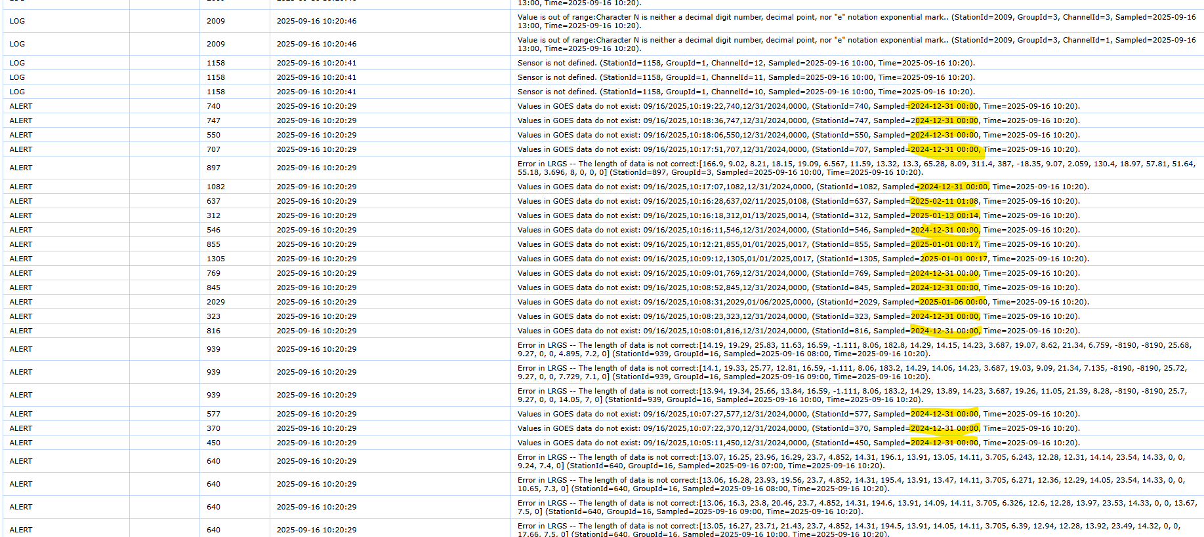
expected results: If sample date is corrupted and date is missing return a NaN or other representation of a missing/bad datetime. Otherwise, the date should be accurate to what the station is reporting the timestamp is.

(priority: medium) BUG: SYSTEM and DATABASE errors are hard to understand and seem to not be functioning correctly.
statement of the problem: The system and database errors do not seem to be working properly. Business staff are uncertain as to what is connected to those tags and what events are supposed to show up. An example is a recent GOES outage in the first week of September 2025 didn’t produce any SYSTEM errors. Additionally, some of the errors that do show up are not very informative (see screen capture of lone errors during the last 30 days). Additionally, several of the DATABASE errors are related to a station and therefore should have an associated station id and telemetry type.
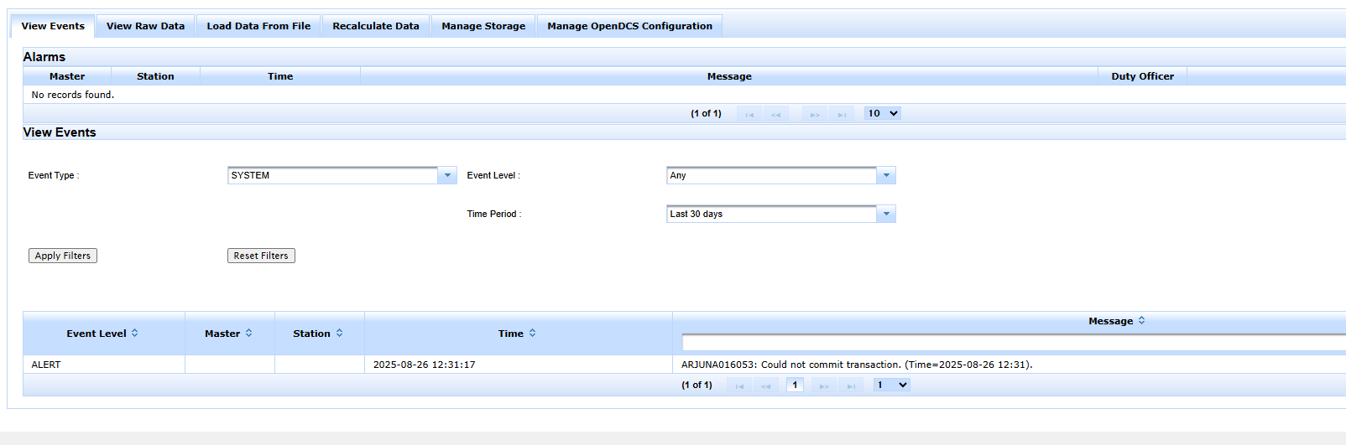
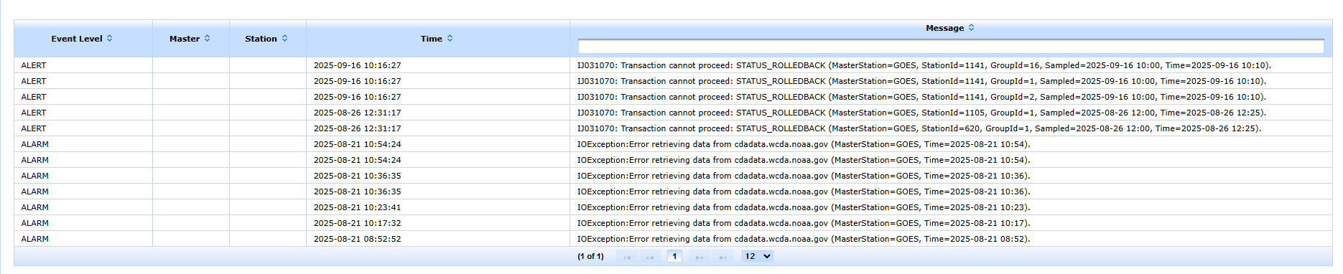
expected results: SYSTEM events should be for system-wide events. A new category in the Station column could be defined called “SYSTEM WIDE”. There should be warnings when external GOES system goes offline. If DATABASE errors are associated with a station, the stations telemetry and id should be populated. Finally, messages should be more helpful and informative. All messages should state the exact component or system the error was generated by.

(priority: low) BUG: WCIS Storage Console View Events - related events for a given station are hard to decipher.
statement of the problem: Often a station configuration issue will trigger multiple events in the View Events tab in the Storage Console. In its current form it is hard for DCO staff to decipher if a given station event is related.
Proposal to fix issue:
Instead of displaying every event, group events by station per hour. Therefore, there is only one entry for a given station per hour of events if that station has any issues. This could look like an accordion menu or a modal for every station with events in each hour. A user then could click on the station, and a menu or modal expands to show all events associated with that station in a given hour.
Additionally, each event could have some sort of color coding to show severity, and the severity is sorted with the most severe first, then the less severe later that would really help DCOs pinpoint the issue. This issue is related to the event categories being ambiguous and often misleading, that is in a separate ticket. If that bug is addressed with more specific categories of issues, each one of those issues could get ranked by severity and then applied to the list for each station. Also, the collapsed (not open) menu could be color coded with the same color as the event with the highest severity for a given station so a user could quickly identify the most critical issues in a list of stations.
expected results: Events associated with the same station are grouped together so that DCO staff can identify related issues.

(priority: low) BUG: WCIS Storage Console View Events - Event categories do not represent the severity of the issue
statement of the problem:
For DCO staff the event categories do not represent the severity of the issue, which is misleading for DCO staff. For example, often LOG events are storage errors which can affect the data quality of a station. I propose to have more precise event categories with an associated severity rating. The DCO staff can sort by those severity ratings, and it helps put the issues in context.
For example, any error or alert message from an outside system should be ranked as a very severe issue. For example, any DADD error messages for GOES systems means that the station is miss configured and could be breaking other stations. Ingestion issues that could be affecting the data quality should have a middle severity rating and issues that the system can correct on the fly and have low risk of data quality issues can be ranked as low severity.
Some Ideas for Potential Categories:
- Cell setup Error - high severity
- Iridium setup Error - high severity
- GOES setup Error - high severity
- Storage Error - mid-severity to low severity
- etc.
Business can help compile a severity ranking for each category of errors.
expected results: All event names (like LOG and ALARM) are replaced by different, more precise labels with an associated severity ranking. The user should be able to quickly identify the severity of any issues.

(priority: low) BUG: WCIS Storage Console View Events - Not an easy way to determine reoccurring issues and when they started.
statement of the problem:
Sometimes a station issue is a one-off event such as a missed transmission. Sometime events are reoccurring. The View Events tab in Storage Console has no easy way to determine if the issue is recurring and when the issue started. A user can look back through record of events, but the event log only goes back so far.
I propose if the same event happens within a 24-hour period of when the prior event occurs, keep a running tally of the number of consecutive days the event occurs. If the event doesn't occur in a 24-hour period but occurs sometime after that, restart the event observed in a day counter. This way DCO staff can pinpoint reoccurring events and figure out when they start.
expected results: DCO staff can quickly identify if an event is a reoccurring issue or a one-time issue. They can also figure out with some associated metadata when the reoccurring issue started.

